

# Department of Computing

# 

**CS110: Fundamentals of Computer Programming**

**Lab 01: Introduction of Python and IDLE (Integrated Development Environment)**

**CLO1: Understand the syntax and semantics of different programming constructs**

**Instructor: Mr. Jaudat Mamoon**

**Lab Engineer: Mr. Danyal Sadiq**

**Master Solution**

#### Installation:

Download the Python 3.x from this link: <https://www.python.org/downloads/>

|  |
| --- |
| Snap of Installation |
|  |

Once downloaded, double click on the .exe file downloaded and run the installation procedure.

You can select the IDLE (Python), by pressing windows key, and type IDLE, select IDLE (Python).

|  |
| --- |
| Snap of Python IDLE |
|  |
|  |

**LAB TASKS**

**(1)**

**Write a program in both scripting and interactive mode, that prints on screen the message Hello, World**

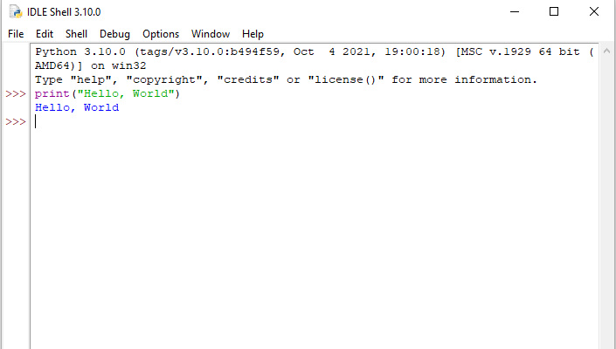

**Input** 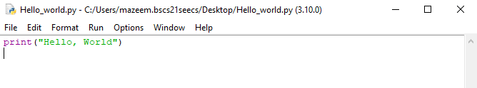

**Output**

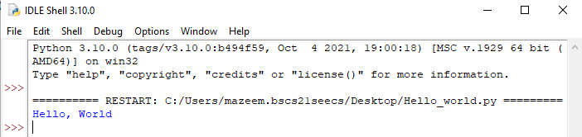

**(2)**

**Using the program in (1), what happens if we remove the closing quotation around the text Hello, World?**

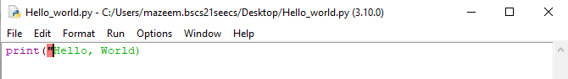

**It will gives syntax error when we remove closing quotation as shown below.**

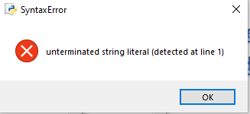

**(3)**

**Using the program in (1), what happens if we remove both the quotations around the text Hello, World? How is it different from the behavior in (2)** 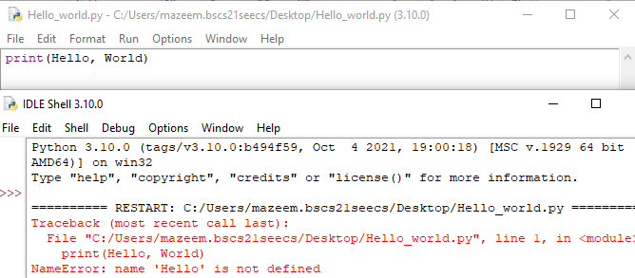

**It gives NameError**

(4)

Write a program using one print() command only that produces the following output

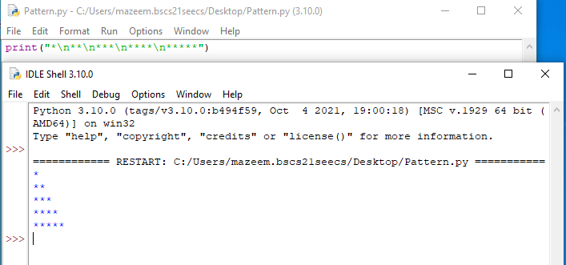

**(5)**

**Write the above program again but without using any escape sequence within the print () command**

